21 September 2024 postcard

Pretty nice breakfast at the Grand Hotel des Îles Boromées, but the tea situation is hopeless. No kettle in the room, no kettle or samovar in the dining room, and one-cup ceramic pots of hot water *already set out and waiting* on a table, cooling all the while. I made do with weak and tepid English breakfast from their assortment of teabags, but tomorrow I'm switching to chocolate.

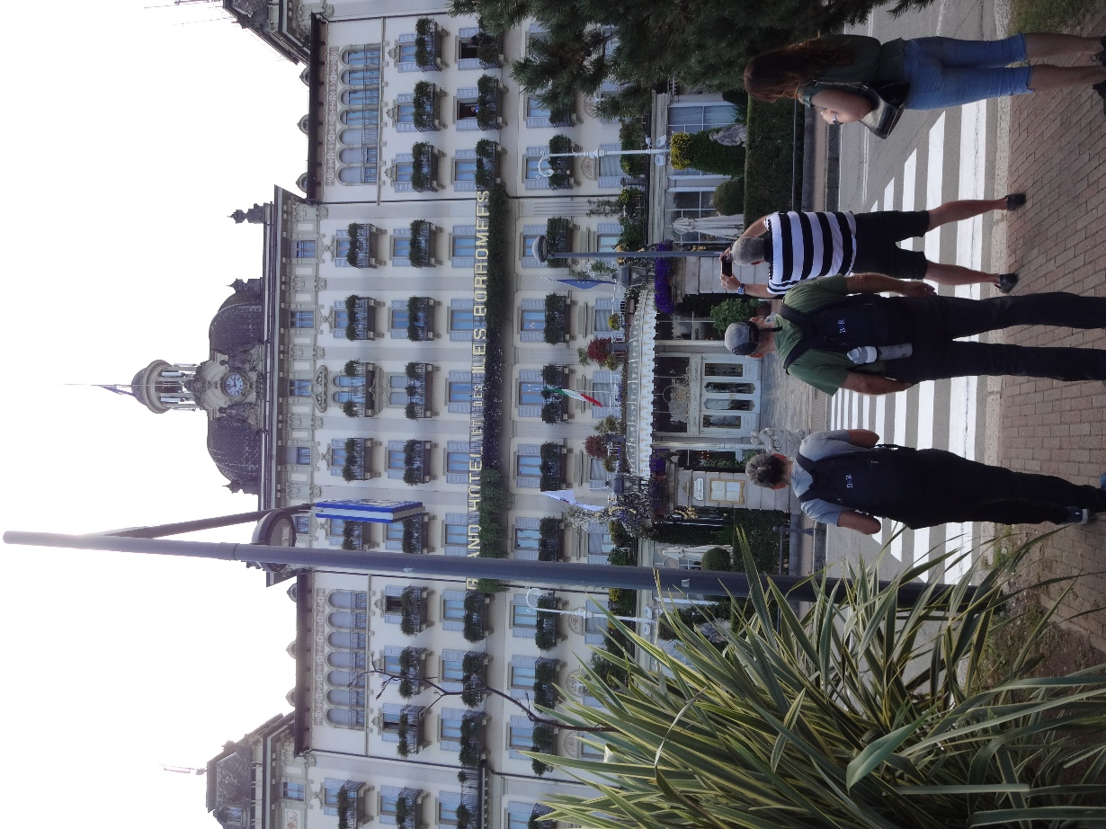Here's a photo of the hotel. The letters "ND H" are attached to David's balcony railing, and "OTE" to mine, so we're front and center, with a breautiful lake view.

At 9 am, we all set off on foot for an orientation tour of the small village of Stresa before boarding another private boat for the brief ride to Isola Bella, one of three islands in the lake collectively known as the "Îles Boromées" (note the Frence influence). The Boromeos are (and have been for a long time) a very wealthy family of Italian nobles. St. Charles Boromeo was one of them. They still own all three islands. Bella is called that not just because it's beautiful but because it was bought, and its elaborate palace built, by a Boromeo prince as a present for his wife, Isabella. So it's not just "Beautiful Island" but "Bella's Island."

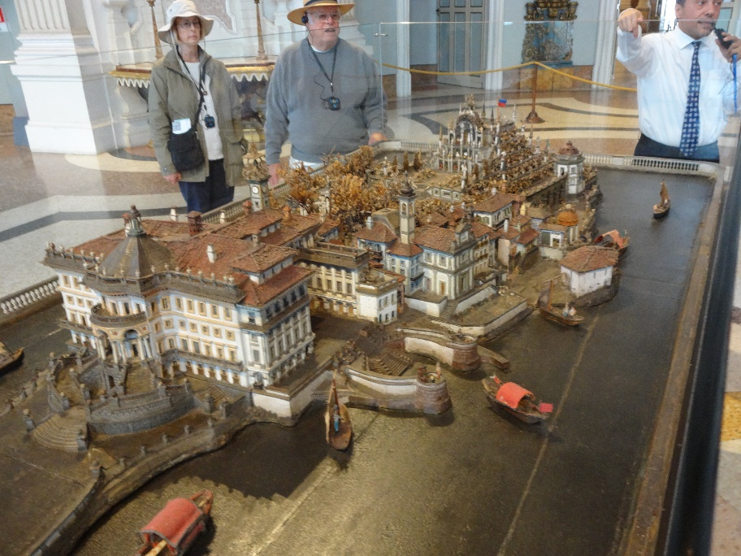We got a guided tour of the palace, which included this model of the original design for the house and grounds, then free time to explore the amazing gardens. Thing is, it's still the summer residence of the Boromeo family, and they are currently still in residence (until the end of the month). They occupy 50 rooms on the top two floors, so we could only visit the ground and first floors. Likewise, the bottom two tiers of the elaborately terraced gardens are reserved for them; we could only visit the top two.

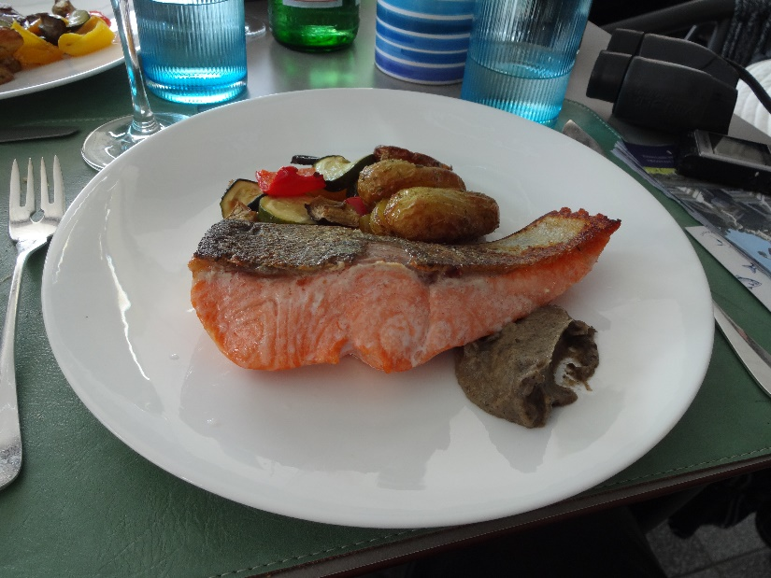

From there, we got back on the boat for the quick trip to Isola dei Pescatori (the third is Isola Madre, the largest, which is a nature preserve occupied by a relatively small palace, turned museum). There we had a truly outstanding three-course lunch at Casabella. I had carpaccio of marinated salmon trout, followed by roasted salmon trout with roasted vegetables (shown here). Dessert was panna cotta with berries and red fruit coulis.

Just as Isola Bella is entirely occupied, edge to edge, by the palace and its gardens, Isola dei Pescatori seems to consist solely of restaurants and souvenir shops, though we came across one little church and its picturesque little cemetery, so I think some people actually live there. After time to explore the island, we met back at the dock to catch our boat back to Stresa and the hotel.

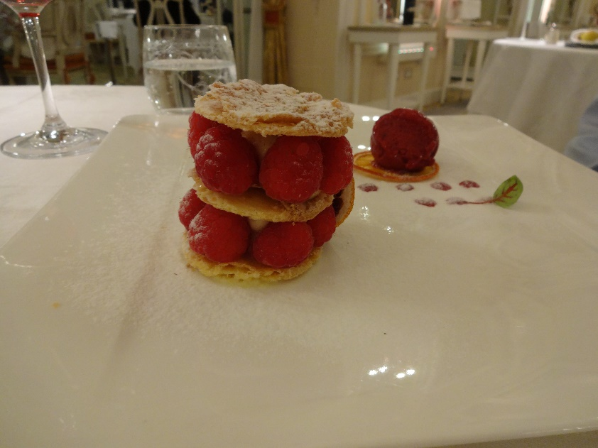We had dinner on our own in the hotel's "fancy" restaurant. The raspberry Napoleon David had for dessert was definitely the most photogenic course: